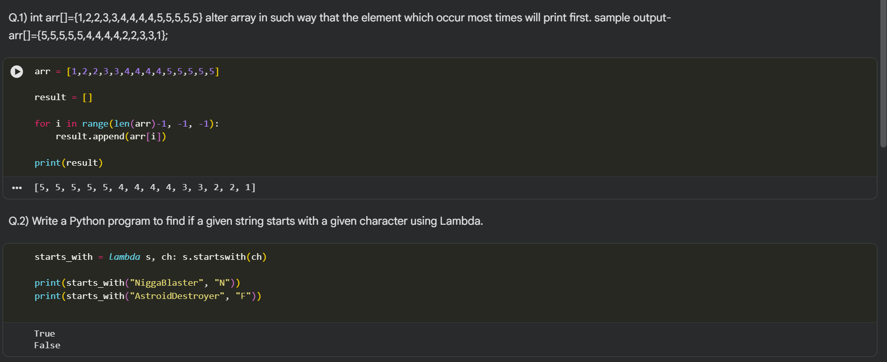

Q.3) Write a Python program to filter a given list whether the values in the list are having length of 6 using Lambda

words = ["cccccc", "dddddd", "eeeeee", "jjjjj", "tttt", "ttrr"]

result = list(filter(lambda x: len(x) == 6, words))

print(result)

